Instructions for Installing Python 3
TE 205 provides an understanding of basic circuits; however, an understanding of microcontrollers opens up many new opportunities as they can be used to automate many simple tasks.
The microcontrollers used in this course are Raspberry Pis which means the primary programming language used to interact with them is Python (which is a real bummer cause you guys would’ve been set if it were vba). Fortunately, this new language is free, (relatively) easy to learn, and is very portable (programs can be easily transferred between mac and windows and linux etc.). So let’s go get python installed on our computers!
To download the python software go to:
https://www.python.org/
I went to the “python for beginners” page instead, it looked something like this:
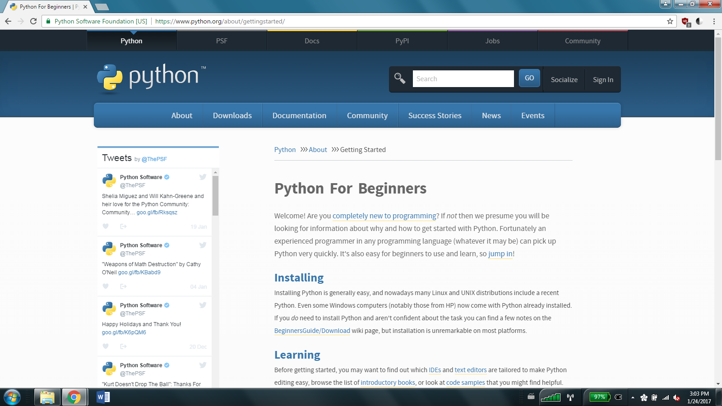

Anyways, go ahead and hover the cursor over the downloads button and a dropdown menu should appear.
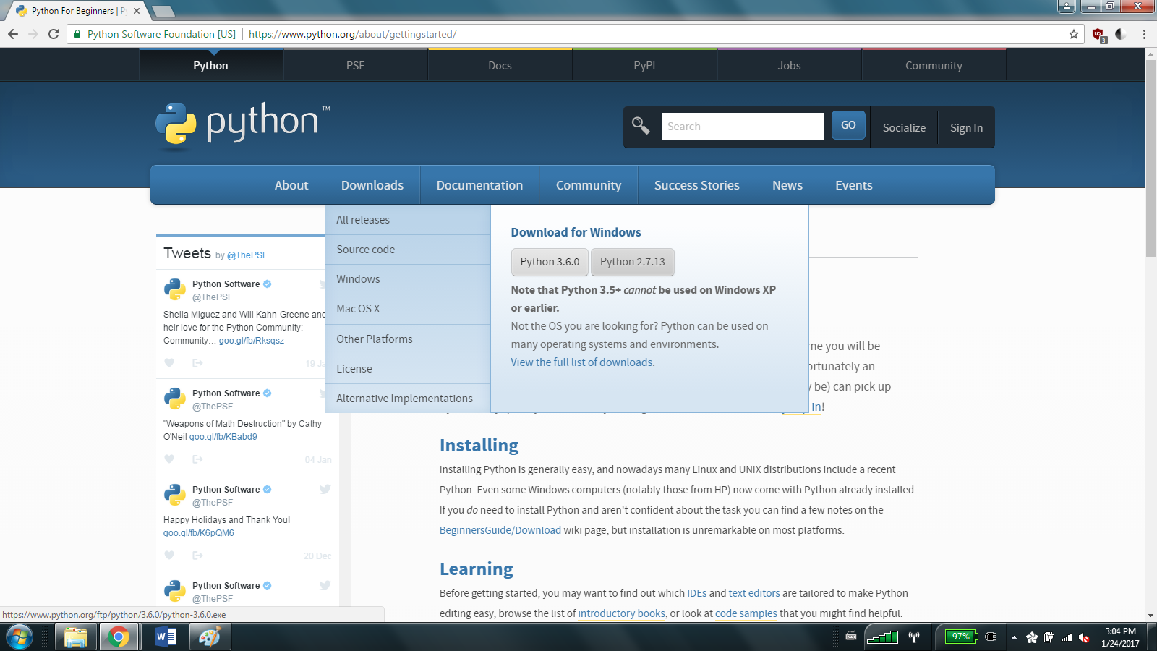
For Windows: go ahead and download the 3 version that’s offered on the drop down.
(if you’re currently running windows XP, you’ll need to find an earlier version of python, or a newer version of windows. I recommend the latter).
Downloads for Mac can be found by clicking on the Mac OS X tab, and then I suggest you download and run the latest Python 3 release.
Warning: Due to financial restriction placed on us, we did not purchase a Mac to test the installation of python, so mac users are slightly on their own from here on out in the guide (but you can still email or meet with us if you have any questions).
If you are using a linux computer, you should probably be teaching us how to install python.

Go ahead and open the executable and it should bring up a window that looks something like this: 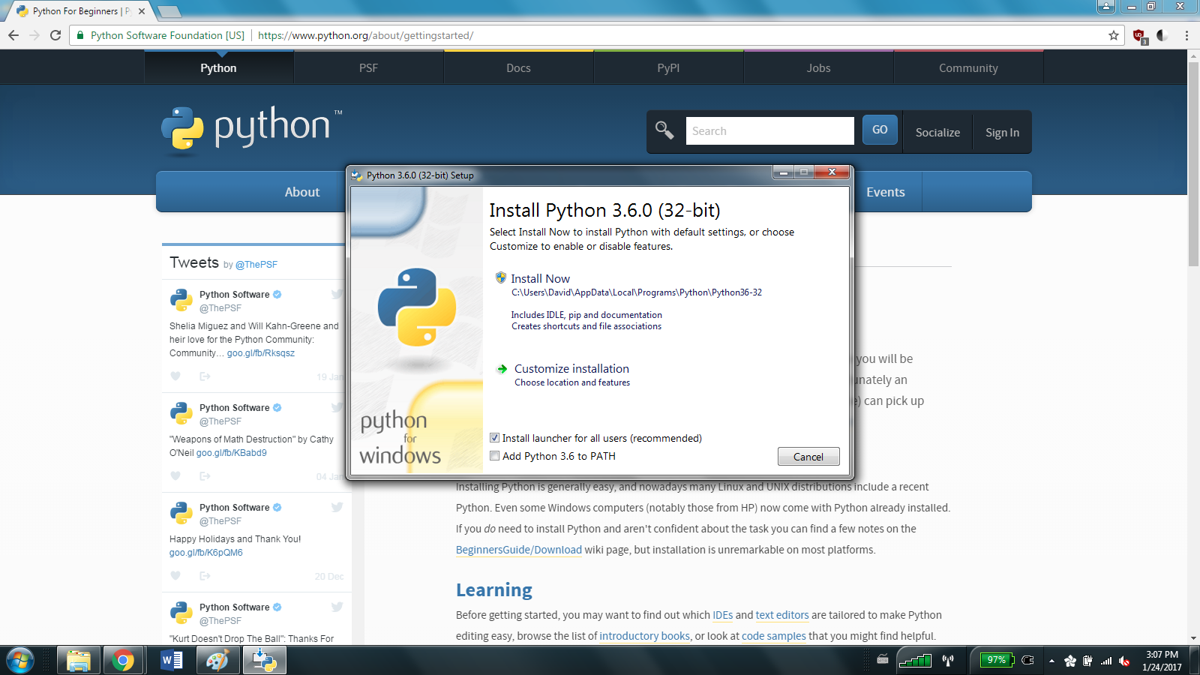
(If it says 64-bit that’s fine for most current computers. It just means that your version of python has a couple extra pieces that let it take advantage of new processor technology).
Anyways, you should click the box that says install a launcher for all users, but the PATH part isn’t really necessary. I skipped it, and my computer was able to run python just fine. Click install now, and your computer will load python onto it. If you normally customize installation feel free to, but this isn’t something I thought was worth exploring.

Hopefully, your screen should look kinda like this now:
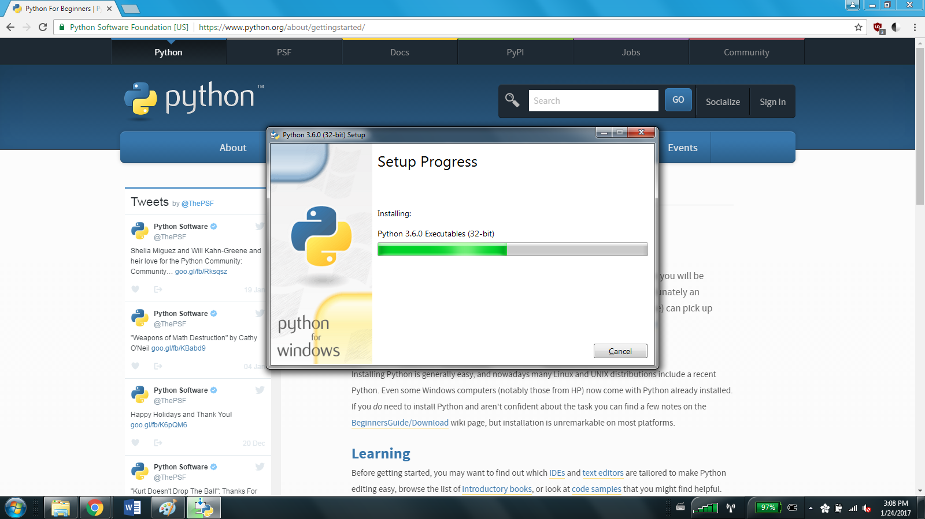
And in a bit, it should look like this:
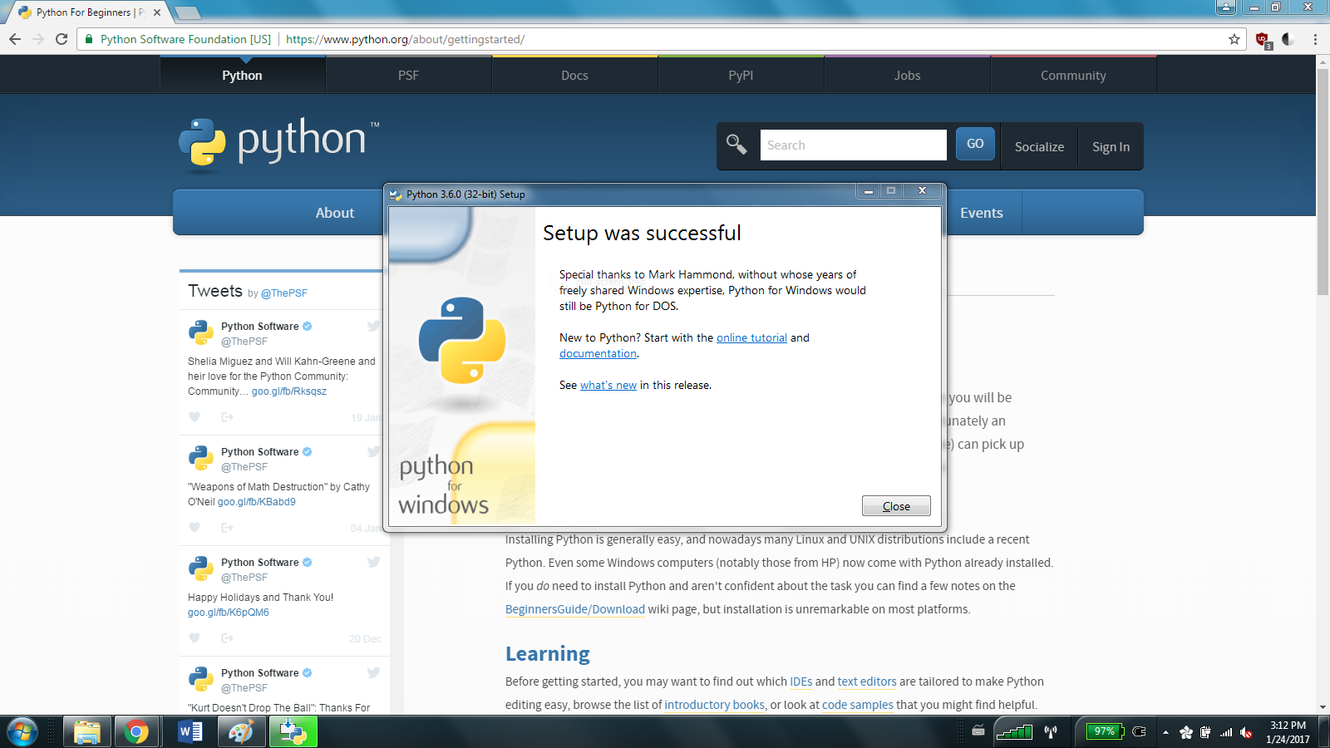

Congratulations! You own a whole new (virtual) computer! You’re done with this set of instructions, and can move onto learning how to python in the next section.

